**1) Task:Worked on IoT Central Jobs Feature.**

**Steps:**

* Open Jobs Section in IoT Central.
* Select Create New Job.
* Enter Configuration: Name of Job , Description of job , Target Device , Job Properties.
* Click Save And Next.
* Enter Delivery Options: Batches and Cancelation Threshold.
* -Batches let stagger jobs for large numbers of devices.
* -The cancellation threshold lets automatically cancel a job if the number of errors exceeds the set limit.
* Click Save And Next.
* Select Schedule: Set the number of time we want to run the job and at what time of day we want to run the job.
* Click Save and Next.
* Review Settings.
* Job is Scheduled Now.

**Types of jobs available are based on : Cloud property, Property, or Command.**

Demo on registering Jobs on Device from IoT Central:

* Purpose of Job was to Raise Target Temperature.
* Job run successfully.
* Target Temperature was raised.

Pic 1)Scheduled Jobs.

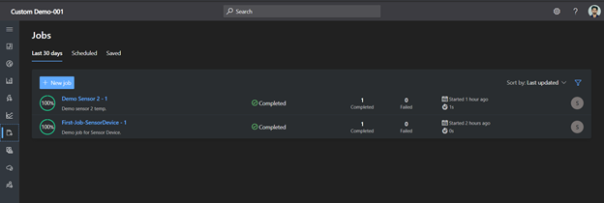

Pic 2)Details of job: Completed, Failed, Pending.

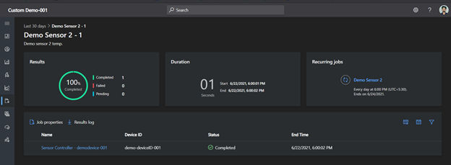

Pic 3)Job Output: Target Temperature was raised.

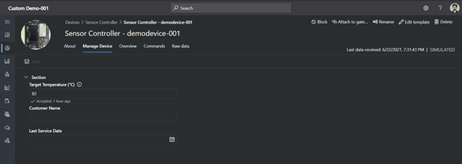

Pic 4) Job Properties.

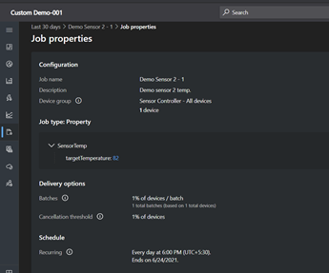

**2)Task No:Worked on listing 6 Edge Gateway Devices and specifications of best fit devices.**

Options of Physical Devices for Edge Runtime so far:

All are Azure Certified Device

Best fit:

-ASUS-PV100A

-xGATEWAY PURE

-CloudPlug edge+

Other fit:

-Advantech-ESRP-CSS-UNO2271

-OpenBlocks IoT VX2

-Advantech-ESRP-CSS-UNO1372

Grounds on what we looked:

Purpose: Collecting data from PLC and transfer data to Azure IoT Hub

Other Requirements:

Min Ram:2 Gb.

Min Rom: 20 Gb with expendable options.

Min CPU: 1GHz to 2 GHz

Os:Linux

Industrial protocol: Ethernet

Connectivity: LAN

Optional: FFC Certified

Specifications of ASUS-PV100A:

Pricing: Around $300

Min Ram: 4 Gb.

Min Rom: 1*16GB onboard eMMC has Extra slot to expand.

Min CPU: 1.3 GHz

Os:Linux Yocto

Industrial protocol: Ethernet (2 port)

Connectivity: LAN

FFC Certified

Specifications of xGATEWAY PURE:

Pricing:$810

Ram:2 Gb.

Rom: 16 GB

CPU: i.MX 8M Mini 1.8 GHz

Os: Linux(Ubuntu 10)

Industrial protocol: Ethernet, CAN_Bus, OPC_Classic, OPC_UA, EtherCAT, Modbus, PROFINET, Others

Connectivity: LAN , Bluetooth, LTE, LoRaWAN, LTE_M, ThreeG, WIFI, FiveG

Specifications of CloudPlug edge+

Pricing: Around $700-$900

Os : Linux(Yocto)

Processor Name: iMX8

Memory: 4 GB

Storage size: 8 GB

Secure hardware: TPM

Connection types: LTE, LAN, WIFI

Industrial protocols: CAN_Bus, OPC_UA, Modbus, Ethernet, others.

Power: 24 V

**3) Task: Worked on adding an Azure IoT Edge device to our Azure IoT Central application**

Earlier facing some errors now found solution for them and Build out end to end demo for the same.

Steps:

-Created Edge Runtime Template in IoT Central and published it.

-Registered Edge Device in IoT Central.

-Added custom telemetry fields.

-Deployed Vm and installed Edge Runtime on it.

-Registered Edge Device on it via symmetric key provisioning.

-Applied the changes in the configuration file.

-Restart iotedge

-Listed Modules.

-Modules deployed successfully.

Pic 1)Modules running on Vm.

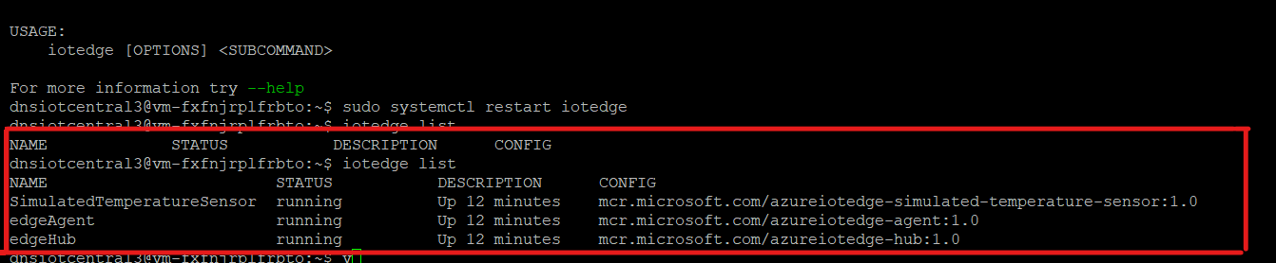

Pic 2) Device Status changed to Provisioned.

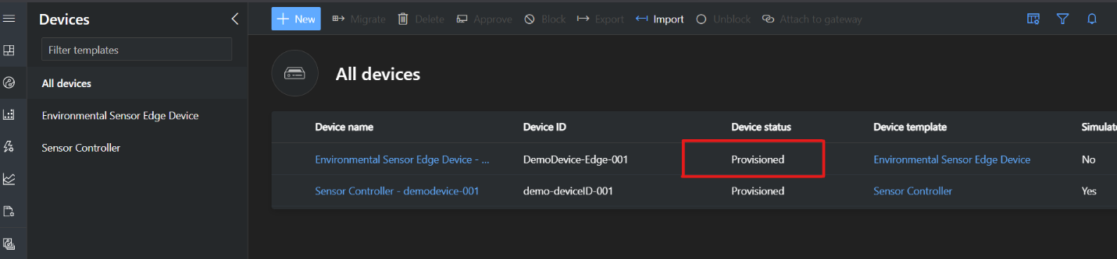

Pic 3)Modules and there Status listed on IoT Central.

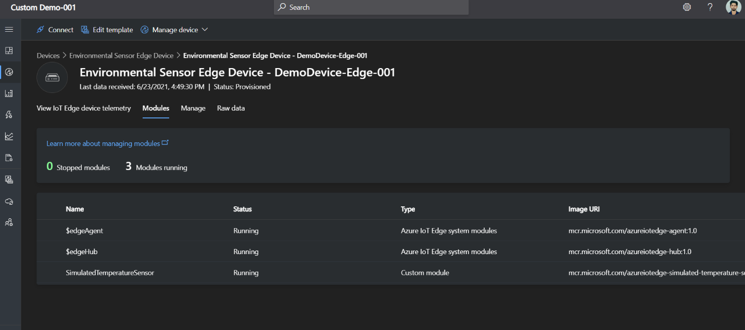

Pic 4) Telemetry Using Dashboard Function.

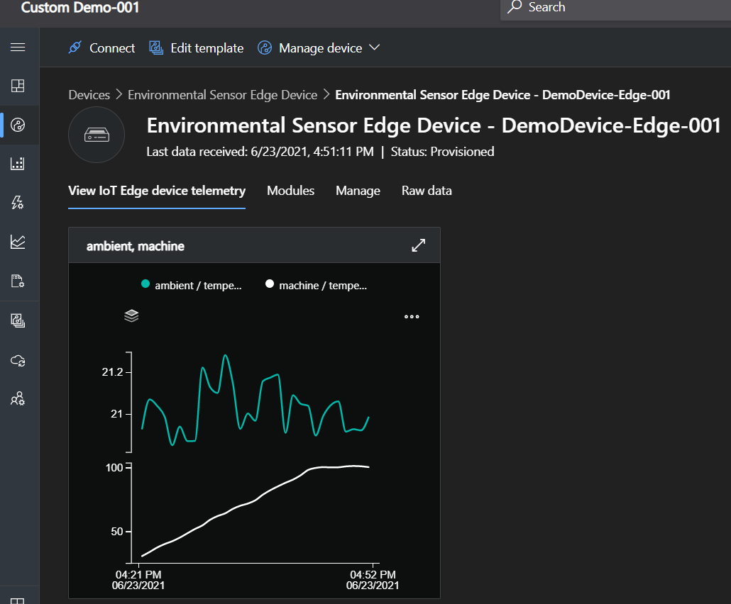

Pic 5)Telemetry Using Raw JSON file we manifested during building template of device.

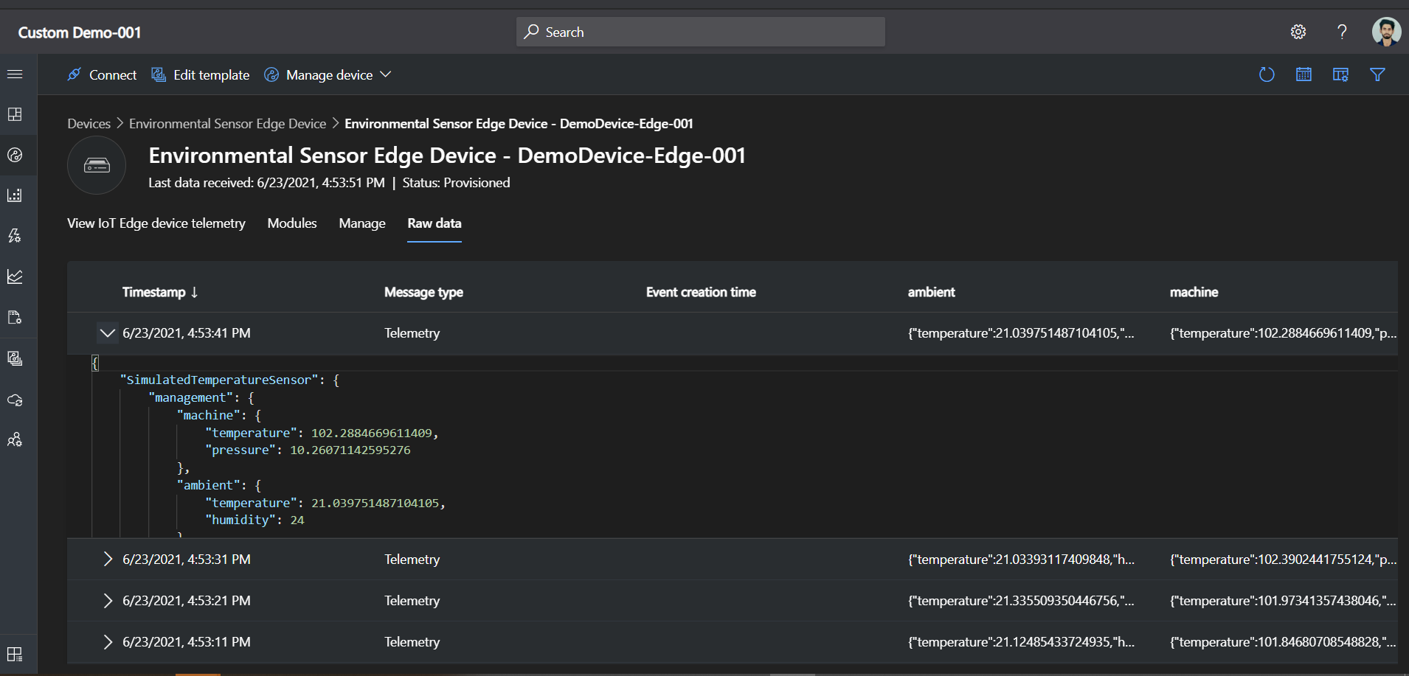

**4) Worked on Pipeline : resolved issue of agent being offline after some time, made it online.**

Agent was being offline after some time.

So, run some commands on Linux Vm to make it online all the time.

**5) Task: Worked on Creating Dashboard for IoT Central.**

**Steps:**

**-Click on Dashboard Section.**

**-Click on Create New.**

**-Select Dashboard name and Dashboard Type.**

**-Click on Create.**

**-Select Device Group.**

**-Select Device.**

**-Select telemetry, properties, and commands from the devices to display.**

**-Add Tile.**

**-Save.**

**-We can also add various conditions to get visuals accordingly.**

**- Now We can see it in our Dashboard Section.**

**(By this time my Azure credits were exhausted but when it will built it would look like the one below which I created during another task)**

